**Patterns in the Lead Growth Rate**

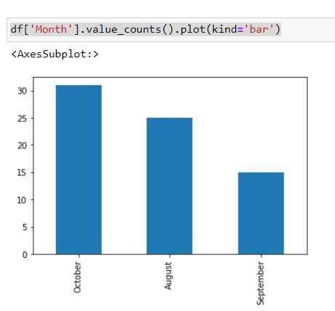The following illustrations show trends in the Lead Growth Rate on a month-by-month basis.

The above illustration shows the total number of visitors on the website, on a month-by-month basis. It is interesting to see that the number of visitors went down by nearly 40% from August to September, but it then rebounded to it’s highest value in the month of October.

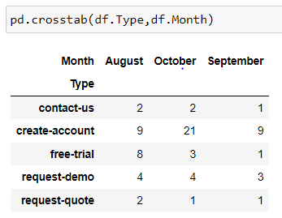October has been a relatively successful month w.r.t. total number of visitors. This may be because of repeat visitors.

The above illustration shows the count of visitors in each month, separated by the “Type” of interaction. The clear outlier here is the 21 new created accounts in the month of October. Hence, here is further evidence that the month of October has been very successful.

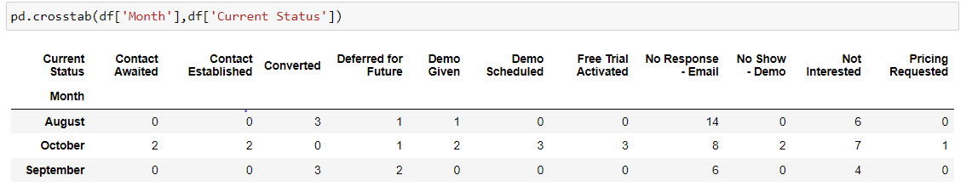

The above illustration shows the count of visitors from each month, separated by their current status. In the month of august a majority of visitors had “No Response – Email” status. **It’s likely that the visitors didn’t find enough relevant information to convince them to use our services further or found alternative solutions.** The “No Response – Email” status count has dropped in the following months.

In conclusion, the website has shown significant improvement in retaining customer interest in the last 2 months.

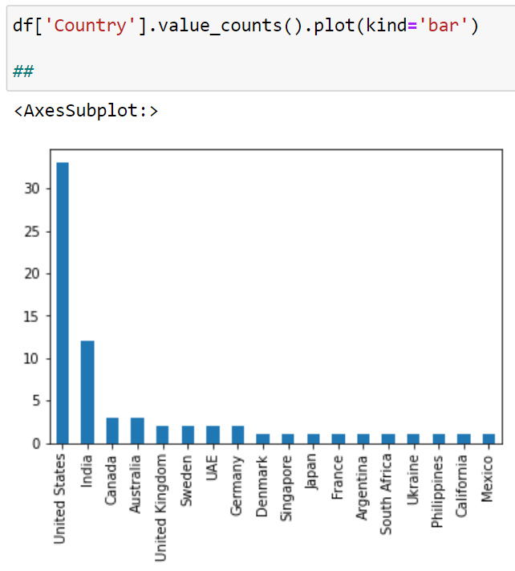**Dominating patterns in Lead Characteristics**

The above illustration shows the number of visitors from each country. Well over 80% of all visitors are from USA and India, suggesting that we should target customers in these regions moving forward.

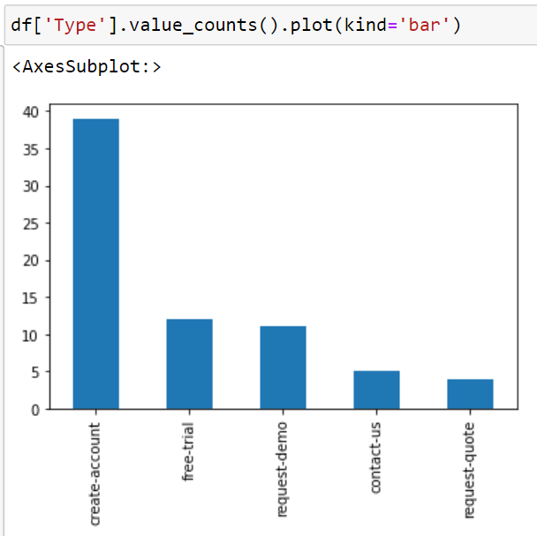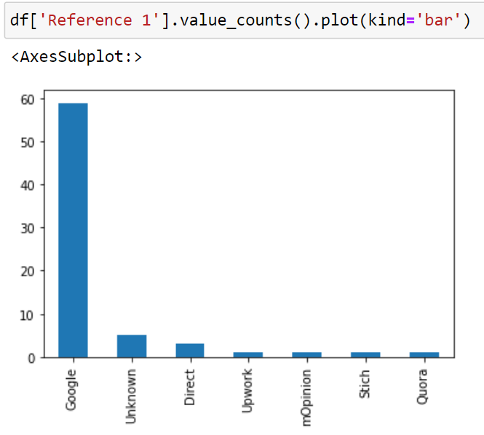The above illustration shows the count of visitors against “Original Referrer”. A majority of the traffic is coming in from Google. This can be safely considered positive feedback on our SEO efforts.

The above illustration shows the number of visitors plotted against their visit “Type”. Over 50% of all visits resulted in “Create-Account”. This suggests that over 50% visitors are finding the information provided in the website as being relevant to their needs.

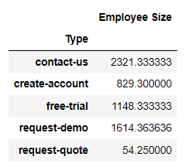

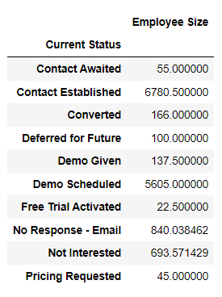The above illustration shows the average “Employee Size” of the visitor’s company against the “Type” of visit. It is clear that very small size companies are more likely to “Request Quote”, and the larger companies are more likely to “Request Demo” or “Contact Us” directly.

The above illustration further supports the conclusions made in the previous illustration. Companies that just “request the price” are likely to be much smaller than companies that have “Demo Scheduled”.

**The pattern in the Blog Traffic Rate and anomalies**

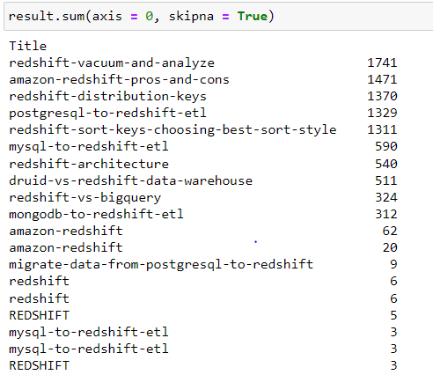

The above illustration shows the top “Blogs” in terms of visitors. The top 5 blogs have enjoyed a majority of all visitors. This insight should guide our choice of blog topics in the future.

Any emerging trends/patterns that you see in terms of Blog Traffic/Conversion

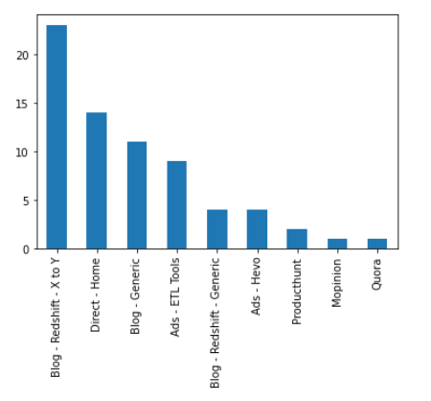

The above illustration shows the number of visitors from different sources. A majority of them are from our top blog post on “Redshift – X to Y”.

